# What is Machine learning?

Machine learning is a branch of computer science which deals with system programming in order to automatically learn and improve with experience. For example: Robots are programed so that they can perform the task based on data they gather from sensors. It automatically learns programs from data.

# How machine learning is different from general programming?

In general programming, we have the data and the logic by using these two we create the answers. But in machine learning, we have the data and the answers and we let the machine learn the logic from them so, that the same logic can be used to answer the questions which will be faced in the future. Also, there are times when writing logic in codes is not possible so, at those times machine learning becomes a saviour and learns the logic itself

# Mention the difference between Data Mining and Machine learning?

Machine learning relates with the study, design and development of the algorithms that give computers the capability to learn without being explicitly programmed. While, data mining can be defined as the process in which the unstructured data tries to extract knowledge or unknown interesting patterns. During this process machine, learning algorithms are used.

# What is inductive machine learning?

The inductive machine learning involves the process of learning by examples, where a system, from a set of observed instances tries to induce a general rule.

# What are the different Algorithm techniques in Machine Learning?

The different types of techniques in Machine Learning are

* 1. Supervised Learning
  2. Unsupervised Learning
  3. Semi-supervised Learning
  4. Reinforcement Learning

# What is the difference between artificial learning and machine learning?

Designing and developing algorithms according to the behaviours based on empirical data are known as Machine Learning. While artificial intelligence in addition to machine learning, it also covers other aspects like knowledge representation, natural language processing, planning, robotics etc.

# What Are the Different Types of Machine Learning?

There are three types of machine learning:

1. **Supervised Learning**

In supervised machine learning, a model makes predictions or decisions based on past or labeled data. Labeled data refers to sets of data that are given tags or labels, and thus made more meaningful.

1. **Unsupervised Learning**

In unsupervised learning, we don't have labeled data. A model can identify patterns, anomalies, and relationships in the input data.

1. **Reinforcement Learning**

Using reinforcement learning, the model can learn based on the rewards it received for its previous action.

# What is the standard approach to supervised learning?

The standard approach to supervised learning is to split the set of example into the training set and the test.

# What is ‘Training set’ and ‘Test set’?

In various areas of information science like machine learning, a set of data is used to discover the potentially predictive relationship known as ‘Training Set’. Training set is an examples given to the learner, while Test set is used to test the accuracy of the hypotheses generated by the learner, and it is the set of example held back from the learner. Training set are distinct from Test set.

# What is Semi-supervised Machine Learning?

Supervised learning uses data that is completely labeled, whereas unsupervised learning uses no training data.

In the case of semi-supervised learning, the training data contains a small amount of labeled data and a large amount of unlabeled data.

# What is Supervised Learning:

It's a type of machine learning where algorithms learn from labeled training data, making predictions or decisions based on that data.

# Classification vs. Regression:

Classification predicts categories or classes while regression predicts continuous values.

# What is Overfitting:

In machine learning, when a statistical model describes random error or noise instead of underlying relationship ‘overfitting’ occurs. When a model is excessively complex, overfitting is normally observed, because of having too many parameters with respect to the number of training data types. The model exhibits poor performance which has been overfit.

# How to identify whether the model has overfitted the training data or not?

This is the step where the splitting of the data into training and validation data proves to be a boon. If the model’s performance on the training data is very high as compared to the performance on the validation data then we can say that the model has overfitted the training data by learning the patterns as well as the noise present in the dataset.

# Why overfitting happens?

The possibility of overfitting exists as the criteria used for training the model is not the same as the criteria used to judge the efficacy of a model.

# How can you avoid overfitting?

To avoid overfitting there are multiple methods that we can use:

* Early stopping of the model’s training in case of validation training stops increasing but the training keeps going on.
* Using regularization methods like L1 or L2 regularization which is used to penalize the model’s weights to avoid overfitting.

By using a lot of data overfitting can be avoided, overfitting happens relatively as you have a small dataset, and you try to learn from it. But if you have a small database and you are forced to come with a model based on that.

In such situation, you can use a technique known as cross validation. In this method the dataset splits into two sections, testing and training datasets, the testing dataset will only test the model while, in training dataset, the datapoints will come up with the model.

In this technique, a model is usually given a dataset of a known data on which training (training data set) is run and a dataset of unknown data against which the model is tested. The idea of cross validation is to define a dataset to “test” the model in the training phase.

# Explain Regularization in Machine Leaning?

Regularization is a technique used in machine learning to prevent overfitting and improve a model's generalization on unseen data. Overfitting occurs when a model learns not only the underlying patterns in the training data but also captures noise and irrelevant information. This leads to poor performance when the model encounters new, unseen data.

There are various forms of regularization, but two common types are:

**L1 Regularization (Lasso):** This method adds a penalty term to the cost function equivalent to the absolute value of the magnitude of coefficients. It tends to force some coefficients to be exactly zero, effectively performing feature selection by eliminating less important features. Lasso regularization can help create simpler models.

**L2 Regularization (Ridge):** This method adds a penalty term to the cost function that is proportional to the square of the magnitude of coefficients. Ridge regularization penalizes large coefficients but does not force them to become zero. It helps in reducing the impact of irrelevant features without eliminating them entirely.

Both L1 and L2 regularization techniques add a regularization term to the standard loss function used for training machine learning models, modifying it to minimize both the error on the training data and the size of the coefficients.

The regularization term is controlled by a hyperparameter (usually denoted as λ or alpha) that balances the tradeoff between fitting the training data well and keeping the model simple. Higher values of λ result in more regularization and tend to produce simpler models with smaller coefficients, reducing the risk of overfitting.

# Explain Cross Validation

Cross-validation is a resampling technique used in machine learning to evaluate the performance of a model on a limited data sample. Its primary goal is to assess how well a trained model will generalize to an independent dataset.

The process involves splitting the dataset into subsets: typically, a training set used to train the model and a validation or test set used to evaluate its performance. Cross-validation takes this a step further by dividing the dataset into multiple **subsets** or "**folds**." The model is trained and evaluated multiple times, using different combinations of these folds.

**K-Fold Cross-Validation:** The dataset is divided into k subsets (or folds) of approximately equal size. The model is trained k times, each time using k-1 folds as the training data and the remaining fold as the validation data. The performance metrics (such as accuracy, precision, or others) are averaged over the k iterations to provide a more robust estimate of the model's performance.

Benefits of Cross-Validation:

* Provides a more reliable estimate of model performance compared to a single train-test split.
* Reduces the variance in performance estimation that may occur due to the randomness of a single split.
* Makes efficient use of available data by using it for both training and validation across multiple iterations.

Cross-validation helps in assessing how well a model generalizes to new, unseen data by simulating the process of training on one set of data and validating on another. It's an essential technique for model evaluation and hyperparameter tuning, helping to identify potential issues such as overfitting or underfitting and guiding improvements in the model's performance.

# Explain how a ROC curve works. (Receiver operating characteristic

The ROC curve is a graphical representation of the contrast between

true positive rates and the false positive rate at various thresholds.

It’s often used as a proxy for the trade-off between the sensitivity of

the model (true positives) vs the fall-out or the probability it will trigger

a false alarm (false positives).

# Define precision and recall.

**Recall is also known as the true positive rate**: the amount of positives

your model claims compared to the actual number of positives there

are throughout the data. Precision is also known as the positive predictive

value, and it is a measure of the amount of accurate positives

your model claims compared to the number of positives it actually

claims. It can be easier to think of recall and precision in the context

of a case where you’ve predicted that there were 10 apples and 5

oranges in a case of 10 apples. You’d have perfect recall (there are

actually 10 apples, and you predicted there would be 10) but 66.7%

precision because out of the 15 events you predicted, only 10 (the

apples) are correct.

# Difference between Precision and Recall

Precision and recall are two fundamental metrics used to evaluate the performance of classification models, particularly in scenarios where the class distribution is imbalanced.

**Precision:** Precision measures the accuracy of the positive predictions made by the model. It's the ratio of correctly predicted positive observations to the total predicted positive observations. In simpler terms, precision answers the question: "Of all the instances predicted as positive, how many are actually positive?" A higher precision indicates fewer false positives.

**Recall (Sensitivity or True Positive Rate):** Recall measures the model's ability to identify all relevant instances, capturing the ratio of correctly predicted positive observations to the total actual positive observations. In other words, recall answers the question: "Of all the actual positive instances, how many did the model correctly identify as positive?" Higher recall implies fewer false negatives.

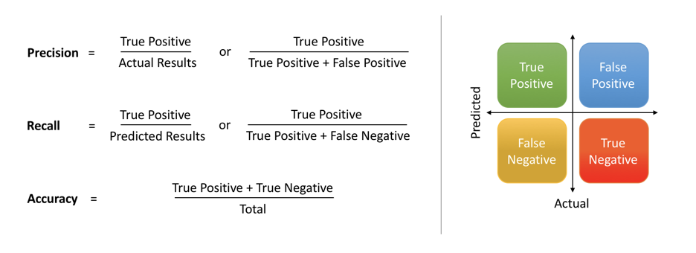

While **precision** focuses on the **accuracy** of positive predictions among all predicted positives, **recall** emphasizes the **completeness** of positive predictions among all actual positives. These metrics often have an inverse relationship: improving one might adversely affect the other. Balancing precision and recall is crucial, especially in cases where misclassification of certain classes is more critical than others (such as in medical diagnostics).

# What’s the difference between Type I and Type II error?

Type I error is a false positive, while Type II error is a false negative.

Briefly stated, Type I error means claiming something has happened

when it hasn’t, while Type II error means that you claim nothing is

happening when in fact something is.

# What’s the F1 score? How would you use it?

The F1 score is a measure of a model’s performance.

It is a weighted average of the precision and recall of a model, with results tending to 1 being the best, and those tending to 0 being the worst.

You would use it in classification tests where true negatives don’t matter much

# How Will You Know Which Machine Learning Algorithm to Choose for Your Classification Problem?

While there is no fixed rule to choose an algorithm for a classification problem, you can follow these guidelines:

If accuracy is a concern, test different algorithms and cross-validate them

If the training dataset is small, use models that have low variance and high bias

If the training dataset is large, use models that have high variance and little bias

# What is Bias in Machine Learning?

Bias in data tells us there is inconsistency in data. The inconsistency may occur for several reasons which are not mutually exclusive.

For example, a tech giant like AMAZON to speed the hiring process they build one engine where they are going to give 100 resumes, it will spit out the top five, and hire those.

When the company realized the software was not producing gender-neutral results it was tweaked to remove this bias.

# Explain the key Difference Between Loss Function and Cost Functions?

When calculating loss we consider only a single data point, then we use the term loss function.

Whereas, when calculating the sum of error for multiple data then we use the cost function. There is no major difference.

In other words, the loss function is to capture the difference between the actual and predicted values for a single record whereas cost functions aggregate the difference for the entire training dataset.

The Most commonly used loss functions are Mean-squared error and Hinge loss.

Mean-Squared Error (MSE): In simple words, we can say how our model predicted values against the actual values.

MSE = √(predicted value - actual value)2

Hinge loss: It is used to train the machine learning classifier, which is

L(y) = max(0,1- yy)

Where y = -1 or 1 indicating two classes and y represents the output form of the classifier. The most common cost function represents the total cost as the sum of the fixed costs and the variable costs in the equation y = mx + b

# What is meant by Bias-Variance Tradeoff

For any model, we have to find the perfect balance between Bias and Variance. This just ensures that we capture the essential patterns in our model while ignoring the noise present it in. This is called Bias-Variance Tradeoff. It helps optimize the error in our model and keeps it as low as possible.

An optimized model will be sensitive to the patterns in our data, but at the same time will be able to generalize to new data. In this, both the bias and variance should be low so as to prevent overfitting and underfitting.

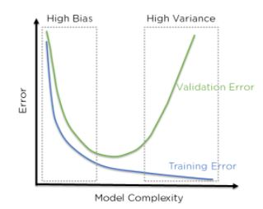

                                     Figure 6: Error in Training and Testing with high Bias and Variance

In the above figure, we can see that when bias is high, the error in both testing and training set is also high.If we have a high variance, the model performs well on the testing set, we can see that the error is low, but gives high error on the training set. We can see that there is a region in the middle, where the error in both training and testing set is low and the bias and variance is in perfect balance.

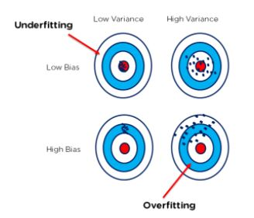

   Bull’s Eye Graph for Bias and Variance

The above bull’s eye graph helps explain bias and variance tradeoff better. The best fit is when the data is concentrated in the center, ie: at the bull’s eye. We can see that as we get farther and farther away from the center, the error increases in our model. The best model is one where bias and variance are both low.

# What are Recommender Systems?

A recommendation engine is a system used to predict users’ interests and recommend products that are quite likely interesting for them.

Data required for recommender systems stems from explicit user ratings after watching a film or listening to a song, from implicit search engine queries and purchase histories, or from other knowledge about the users/items themselves

# What is the difference between the content-based and collaborative filtering algorithms of recommendation systems?

In a content-based recommendation system, similarities in the content and services are evaluated, and then by using these similarity measures from past data we recommend products to the user.

But on the other hand, in collaborative filtering, we recommend content and services based on the preferences of similar users.

For example, if one user has taken A and B services in past and a new user has taken service A then service A will be recommended to him based on the other user’s preferences.

# What is a Hypothesis in Machine Learning?

A hypothesis is a term that is generally used in the Supervised machine learning domain. As we have independent features and target variables and we try to find an approximate function mapping from the feature space to the target variable that approximation of mapping is known as a hypothesis.

# Why do we take smaller values of the learning rate?

Smaller values of learning rate help the training process to converge more slowly and gradually toward the global optimum instead of fluctuating around it. This is because a smaller learning rate results in smaller updates to the model weights at each iteration, which can help to ensure that the updates are more precise and stable.

If the learning rate is too large, the model weights can update too quickly, which can cause the training process to overshoot the global optimum and miss it entirely.

# Explain Confusion Matrix

Confusion matrix summarizes the performance of a classification model. In a confusion matrix, we get four types of output (in case of a binary classification problem) which are TP, TN, FP, and FN.

As we know that there are two diagonals possible in a square, and one of these two diagonals represents the numbers for which our model’s prediction and the true labels are the same.

Our target is also to maximize the values along these diagonals. From the confusion matrix, we can calculate various evaluation metrics like accuracy, precision, recall, F1 score, etc.

# What is the difference between stochastic gradient descent (SGD) and gradient descent (GD)?

In the gradient descent algorithm train our model on the whole dataset at once.

But in Stochastic Gradient Descent, the model is trained by using a mini-batch of training data at once.

If we are using SGD then one cannot expect the training error to go down smoothly.

The training error oscillates but after some training steps, we can say that the training error has gone down.

Also, the minima achieved by using GD may vary from that achieved using the SGD.

May be the minima achieved by using SGD are close to GD but not the same.

# What is the Central Limit theorem?

The Central Limit Theorem states that when you take lots of samples from any population, the average of those samples will follow a bell-shaped curve (a normal distribution), even if the original population isn't shaped like a bell. This helps us use methods like averages and confidence intervals, assuming we have big enough samples.

# What is Linear Discriminant Analysis?

LDA is a supervised machine learning dimensionality reduction technique because it uses **target** variables also for dimensionality reduction. It is commonly used for classification problems. The [LDA](https://www.geeksforgeeks.org/ml-linear-discriminant-analysis/) mainly works on two objectives:

* Maximize the distance between the means of the two classes.
* Minimize the variation within each class.

# Does the accuracy score always a good metric to measure the performance of a classification model?

No, there are times when we train our model on an imbalanced dataset the accuracy score is not a good metric to measure the performance of the model. In such cases, we use precision and recall to measure the performance of a classification model. Also, f1-score is another metric that can be used to measure performance but in the end, f1-score is also calculated using precision and recall as the f1-score is nothing but the harmonic mean of the precision and recall.

# What is the reason behind the curse of dimensionality?

As the dimensionality of the input data increases the amount of data required to generalize or learn the patterns present in the data increases.

For the model, it becomes difficult to identify the pattern for every feature from the limited number of datasets or we can say that the weights are not optimized properly due to the high dimensionality of the data and the limited number of examples used to train the model.

Due to this after a certain threshold for the dimensionality of the input data, we have to face the curse of dimensionality

# Explain radial basis function

RBF (radial basis function) is a real-valued function used in machine learning whose value only depends upon the input and fixed point called the centre. The formula for the radial basis function is as follows:

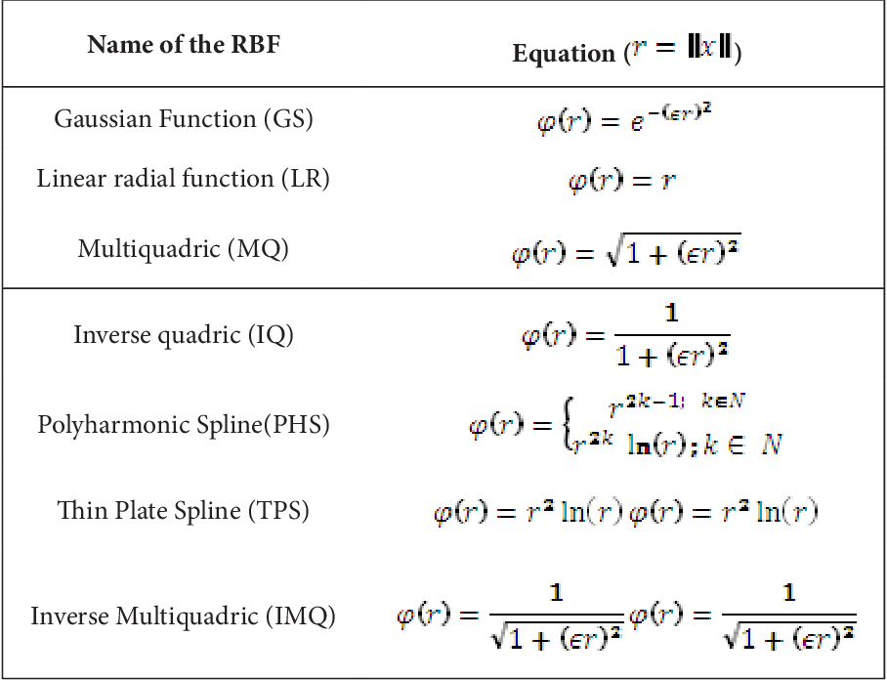

Machine learning systems frequently use the RBF function for a variety of functions, including:

* RBF networks can be used to approximate complex functions. By training the network’s weights to suit a set of input-output pairs,
* RBF networks can be used for unsupervised learning to locate data groups. By treating the RBF centers as cluster centers,
* RBF networks can be used for classification tasks by training the network’s weights to divide inputs into groups based on how far from the RBF nodes they are.

It is one of the very famous kernels which is generally used in the SVM algorithm to map low dimensional data to a higher dimensional plane so, we can determine a boundary that can separate the classes in different regions of those planes with as much margin as possible.

# What are the requirements of reinforcement learning environments?

State, reward data, agent, and environment. It is entirely different from other machine learning paradigms. Here we have an agent and an environment. The environment refers to a task or simulation; the agent is an algorithm that interacts with the environment and tries to solve it.

# What does the area under the ROC curve indicate?

ROC stands for Receiver Operating Characteristic. It measures the usefulness of a test where the larger the area, the more useful the test. These areas are used to compare the effectiveness of the tests. A higher AUC (area under the curve) generally indicates that the model is better at distinguishing between the positive and negative classes. AUC values range from 0 to 1, with a value of 0.5 indicating that the model is no better than random guessing, and a value of 1 indicating perfect classification.



# What is the time series?

# Time series is a particular sequence of data observations in successive order collected over a period. It usually does not need any maximum or minimum time input. It basically forecasts target values based solely on a known history of target values. It is used to predict time-based predictions such as signal processing, engineering domain- communications and control systems, and weather forecasting models.

# What is sensitivity?

# This is the probability that the prediction outcome of the model is true when the

# value is positive. It can be described as the metric for evaluating a model’s ability

# to predict the true positives of each available category. Sensitivity = TP / TP+FN

# (i.e. True Positive/True Positive + False Negative)

# What is specificity?

# This is the probability the prediction of the model is negative when the actual

# value is negative. It can be termed as the model’s ability to foretell the true

# negative for each category available. Specificity = TN / TN + FP (i.e. True

# Negative/True Negative + False Positive)

# Explain Kernel SVM.

# Kernel SVM stands for Kernel Support Vector Machine. In SVM, a kernel is a

# function that aids in problem-solving. They provide shortcuts to help you avoid

# doing complicated math. The amazing thing about kernel is that it allows us to go

# to higher dimensions and execute smooth computations. Kernel SVMs can work

# with a variety of kernel functions, including linear, polynomial, and radial basis

# function (RBF) kernels, among others.

# How can you differentiate between a parametric and a non-parametric model?

# Parametric models have limited parameters and only need to know the model's

# parameters to predict new data, whereas non-parametric models have unlimited

# parameters and have more flexibility in new data prediction.

# What differences exist between Softmax and Sigmoid functions?

# The sigmoid function is a mathematical function that maps any input value to

# value between 0 and 1 and it is used for binary classification.

# On the other hand, the softmax function is used for multi-classification, and the

# sum of the probabilities will be 1.

# What different methods to avoid overfitting

# Cross validation

# Custom feature selection

# Data augmentation

# Using larger datasets

# Data simplification

# Ensembling

# Regularization

# Which is better to have? A false positive or false negative?

# It depends on the situation. A false negative is risky in fields like medicine when a

# virus is scanned and reported absent when it is present. A false positive is risky in situations like spam email detection because it can classify an important email as spam.

# Explain the reason for pruning of a decision tree.

# Pruning is the process of removing unnecessary nodes in a decision tree in order to reduce the complexity and improve the generalization accuracy of the model. It is used to prevent overfitting. Pruning helps in reducing the complexity of the decision trees by removing the nodes that do not have a great impact on the prediction accuracy.

# What sort of optimization problem would you be solving to train a support vector machine?

# Maximize margin (best answer),

# quadratic program,

# quadratic with linear constraints,

# reference to solving the primal or dual form.

# What are some tools for parallelizing machine learning algorithms?

# Parallelizing machine learning involves running different parts of the learning process simultaneously on multiple computing resources, like multiple CPU cores or GPUs. It's done to speed up training by splitting the workload and performing computations concurrently. This helps handle large datasets or complex models more efficiently. Techniques include dividing data for simultaneous training (data parallelism), splitting models across devices (model parallelism), or using multiple machines (distributed computing)

# Data Parallelism: Training multiple copies of the model on different parts of the dataset simultaneously.

# Model Parallelism: Splitting a large model across multiple devices for independent training.

# Mini-Batch Gradient Descent: Calculating gradients for mini-batches of data concurrently.

# Parameter Servers: Distributing model parameters across servers for parallel updates.

# Ensemble Methods: Training multiple models independently and combining their outputs.

# GPU Acceleration: Using GPUs for faster computation in deep learning.

# Distributed Computing Frameworks: Tools like TensorFlow for distributed training.

# MapReduce Paradigm: Parallel processing for large-scale data tasks.

# Pipeline Parallelism: Running different stages of the ML pipeline concurrently.

# GPUs, Matlab parfor, write your own using low level primitives/RPC/MPI, mapreduce, spark, vowpal, graphlab, giraph, petuum, parameterserver

# Why is Bayes referred to as “Naive Bayes?

Naive Bayes is referred to as “naive” because despite having many practical applications it is based on the assumption that it is impossible to find real-life data.

All the features in a data set are independent, equal, and crucial. In the naive Bayes approach, conditional probability is computed as a pure product of the probabilities of individual components thus implying the complete independence of features. Sadly, this assumption can never occur in a real-life situation.

# What are the two methods for calibration in supervised learning?

The two calibration methods are isotonic regression and Platt calibration. Both these methods are designed especially for binary classification.

# Why do you prune a Decision Tree?

They are pruned to get rid of the branches with weak predictive abilities. Pruning can be either done from the top-down or bottom-up. It helps to minimize the complexity quotient of the Decision Tree model and optimize its predictive accuracy. Cost-complexity pruning, minimum error pruning, reduced error pruning, error complexity pruning are some of the used Decision Tree pruning methods.

# Explain backpropagation algorithm.

# Backpropagation is a key algorithm used in training neural networks. It calculates

# the gradients of the loss function with respect to the weights by working backward

# through the network. These gradients guide the adjustments made to the weights

# during training, allowing the network to learn and improve its predictions by

# minimizing errors.

# Differentiate between generative and discriminative models and give examples of each.

# Generative and discriminative models are two fundamental approaches in machine learning, differing in how they learn and utilize data.

# Generative Models: These models learn the underlying probability distribution of the input data and generate new samples that resemble the training data. They focus on understanding how the data was generated and can create new data points. Examples include:

# Naive Bayes: A probabilistic classifier that assumes independence among features given the class. It's used for classification tasks.

# Variational Autoencoders (VAEs): A type of neural network that learns latent representations and can generate new data points similar to the training data.

# Generative Adversarial Networks (GANs): A framework involving two neural networks - a generator and a discriminator. GANs generate new data that is realistic enough to fool the discriminator.

# Discriminative Models: These models learn the boundary or decision boundary between classes directly, focusing on predicting the target variable given the input data. They aim to learn the mapping from input features to the output label without explicitly modeling the data generation process. Examples include:

# Logistic Regression: A linear model used for binary classification tasks that models the probability of the input belonging to a certain class.

# Support Vector Machines (SVM): An algorithm that finds the hyperplane that best separates different classes in high-dimensional space.

# Neural Networks (for classification): Deep learning models like feedforward neural networks, convolutional neural networks (CNNs), or recurrent neural networks (RNNs) used for classification tasks.

# Key Differences:

# Focus: Generative models focus on understanding the underlying data distribution and can generate new samples. Discriminative models concentrate on learning the boundary between classes for prediction.

# Usage: Generative models can be used for generating new data and understanding the data generation process. Discriminative models are primarily used for classification or regression tasks.

# Both types have their strengths and weaknesses, and the choice between them depends on the specific task and the nature of the data available

# What are the ethical considerations in machine learning?

# Ethical considerations in machine learning are critical due to the potential impact of AI and ML systems on individuals, society, and various industries. Some key ethical considerations include:

# Bias and Fairness: AI systems can inherit biases present in the training data, leading to discriminatory outcomes. Ensuring fairness and mitigating biases in algorithms is crucial to prevent discrimination against certain groups based on race, gender, or other sensitive attributes.

# Transparency and Explainability: The "black box" nature of some complex models makes it challenging to understand how they arrive at decisions. Ensuring transparency and explainability in AI systems is important for building trust and accountability, especially in high-stakes applications like healthcare or criminal justice.

# Privacy: AI systems often deal with sensitive personal data. Protecting user privacy by implementing robust data protection measures and ensuring compliance with regulations like GDPR is essential.

# Security and Robustness: Ensuring that AI systems are secure against adversarial attacks and are robust enough to handle unexpected scenarios is crucial. Vulnerabilities in AI systems can lead to serious consequences, particularly in critical systems like autonomous vehicles or healthcare.

# Accountability and Responsibility: Establishing accountability for the decisions made by AI systems is important. Who is responsible for errors or harm caused by AI decisions? Developing frameworks to assign responsibility is a critical ethical consideration.

# Impact on Jobs and Society: AI and automation have the potential to disrupt job markets, leading to job displacement. Addressing the societal impact of AI on employment and taking measures to reskill and upskill the workforce is essential.

# Data Governance and Bias Mitigation: Ensuring responsible data collection, data governance, and continuous monitoring for biases in datasets used for training models are crucial steps to mitigate bias propagation in AI systems.

# Regulation and Governance: Establishing ethical guidelines, standards, and regulatory frameworks to govern the development, deployment, and use of AI technologies is crucial to ensure responsible and ethical AI adoption.

# Addressing these ethical considerations requires collaboration among various

# stakeholders, including policymakers, industry experts, ethicists, and technologists, to

# ensure the development and deployment of AI systems that benefit society while

# respecting ethical principles and human values.

Explain the concepts of Machine Learning, Artificial Intelligence, and Deep Learning.

2. What do Bias and Variance refer to in Machine Learning?

3. Define Clustering in the context of Machine Learning.

4. Elaborate on Linear Regression in Machine Learning.

5. Provide an overview of Decision Trees in Machine Learning.

7. Explain the concept of Hypothesis in Machine Learning.

10. Define Bayes's Theorem in the context of Machine Learning.

11. Describe the purpose of Principal Component Analysis (PCA) in Machine Learning.

12. What is Support Vector Machine (SVM) in Machine Learning?

13. Define Cross-validation in Machine Learning.

14. Explain the concept of Entropy in Machine Learning.

15. What does Epoch signify in Machine Learning?

17. Define Precision and Recall.

18. How can Overfitting and Underfitting be addressed?

19. What is a Neural Network?

21. What is Ensemble Learning?

22. How do you determine which Machine Learning Algorithm to use?

24. What is a Random Forest, and how does it function?

25. Differentiate between Collaborative Filtering and Content-Based Filtering.

26. Define Clustering.

27. Methods for selecting the value of K in K-means Clustering.

29. Techniques to assess the Normality of a dataset.

30. Can logistic regression be used for more than two classes?

31. Explain Correlation and Covariance.

32. Define P-value.

33. Differentiate between Parametric and Non-Parametric Models.

34. What is Reinforcement Learning?

35. Differences between Sigmoid and Softmax functions.

* What are projects you have done (Important one)
  + Based on algorithm you have used they will ask details about it like
    - Why this algorithm only?
    - Where did you get data from
    - Why that hyper-parameter?
    - What was the result
    - Any data visualisation techniques you have used?
    - On which basis you declared model fit for testing?
    - What is the concept of that algo
  + It is an endless cycle once you are into the project section. So it is better to take interviewer towards the projects. But most importantly clear all the concepts which occur into the project you show in resume.